You are given a 2D integer array descriptions where descriptions[i] = [parenti, childi, isLefti] indicates that parenti is the **parent** of childi in a **binary** tree of **unique** values. Furthermore,

* If isLefti == 1, then childi is the left child of parenti.
* If isLefti == 0, then childi is the right child of parenti.

Construct the binary tree described by descriptions and return *its* ***root***.

The test cases will be generated such that the binary tree is **valid**.

**Example 1:**

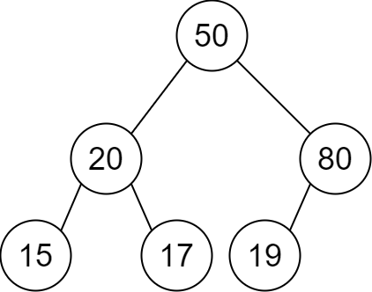

Input: descriptions = [[20,15,1],[20,17,0],[50,20,1],[50,80,0],[80,19,1]]  
Output: [50,20,80,15,17,19]  
Explanation: The root node is the node with value 50 since it has no parent.  
The resulting binary tree is shown in the diagram.

**Example 2:**

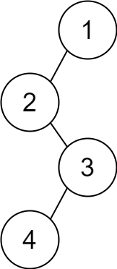

Input: descriptions = [[1,2,1],[2,3,0],[3,4,1]]  
Output: [1,2,null,null,3,4]  
Explanation: The root node is the node with value 1 since it has no parent.  
The resulting binary tree is shown in the diagram.

**Constraints:**

* 1 <= descriptions.length <= 104
* descriptions[i].length == 3
* 1 <= parenti, childi <= 105
* 0 <= isLefti <= 1
* The binary tree described by descriptions is valid.